- Git HandsOn

Step 1: Setup your machine with Git Configuration
To create a new repository, signup with GitLab and register your credentials
Login to GitLab and create a “GitDemo” project

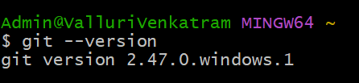
- To check if Git client is installed properly: Open Git bash shell and execute

If output shows Git with its version information that indicates, that Git Client installs properly.
- To configure user level configuration of user ID and email ID execute
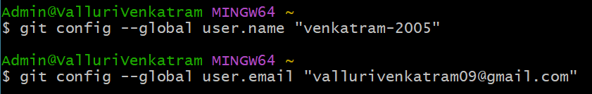
- To check if the configuration is properly set, execute the following command.
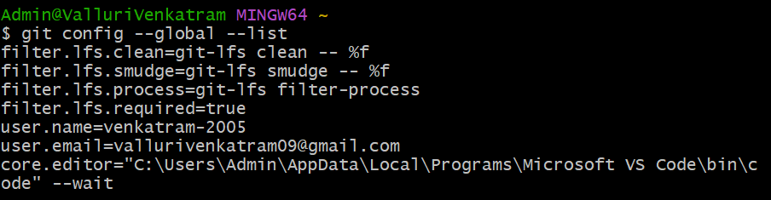

Step 2: Integrate notepad++.exe to Git and make it a default editor
To add path of notepad++.exe to environment variable, go to control panel -> System -> Advanced System settings. Go to Advanced tab -> Environment variables -> Add path of notepad++.exe to the path user variable by clicking on “Edit”
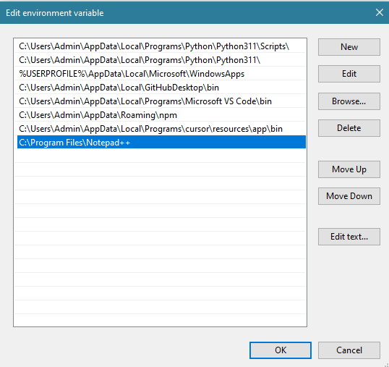

- Exit Git bash shell, open bash shell and execute
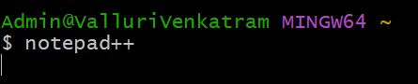
Now, notepad++ will open from Git bash shell
- To configure the editor, execute the command
- To verify if notepad++ is the default editor, execute the command
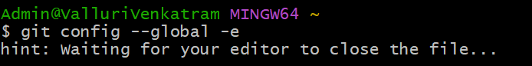

It will show the entire global configuration as shown below,
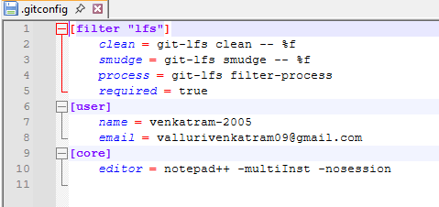

Step 3: Add a file to source code repository
- Open Git bash shell and create a new project “GitDemo” by executing the command
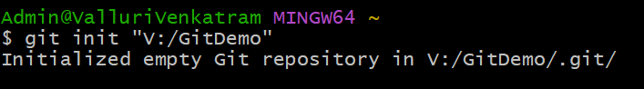
- Git bash initializes the “GitDemo” repository. To verify, execute the command
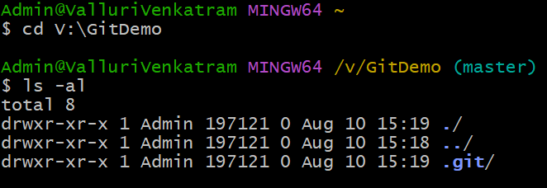

- To create a file “welcome.txt” and add content to the file, execute the command

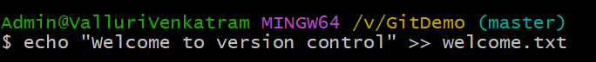
- To verify if the file “welcome.txt” is created, execute
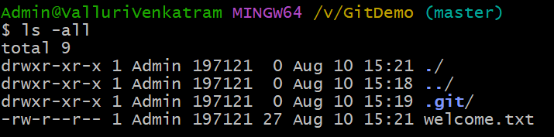
- To verify the content, execute the command
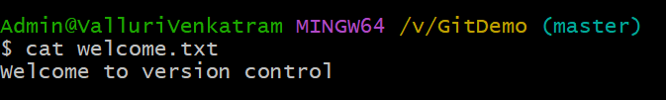
- Check the status by executing
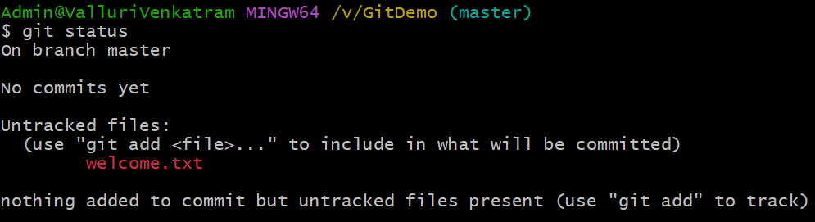

- To make the file to be tracked by Git repository, execute the command
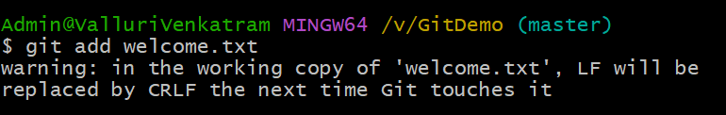

- To add multi line comments, we are opening default editor to comment. Execute the command

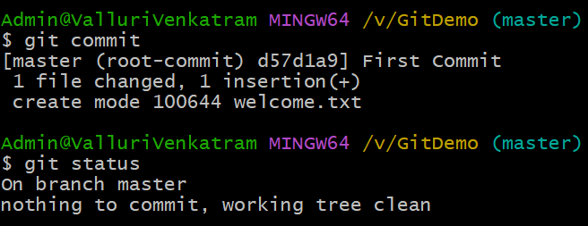
- To check if local and “Working Directory” git repository are same, execute git status
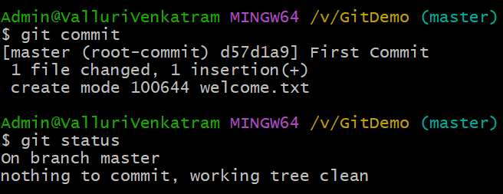

- Signup with GitLab and create a remote repository “GitDemo”
Add remote origin and push the code to remote repository

